DISCUSSION GUIDES TO ACCOMPANY HANDOUTS:
VERSION 2_ENGLISH

This document provides discussion guides to discuss the following handouts with caregivers, either in person, or over the phone.

- R@H_V2_HANDOUTS 1_INTRODUCTION
- R@H_V2_HANDOUTS 2_BENEFITS
- R@H_V2_HANDOUTS 3_BEFORE, DURING, AFTER
- R@H_V2_HANDOUTS 1_DISABILITY

RELEVANT HANDOUT: R@H_V2_HANDOUTS 1_INTRODUCTION

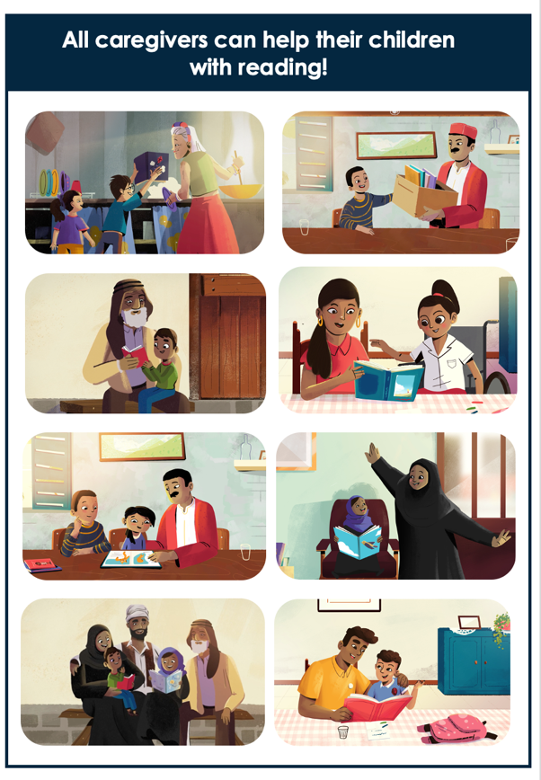 | Explain: As a caregiver, your involvement in reading activities is important at every age – whether your child is very young, or whether your child already knows how to read.  All caregivers can help their children with reading. Even caregivers who cannot read themselves, who are busy or who don’t see children every day can help children with learning and reading in important ways.  By making some time each day to look at books together and talk about the pictures, you can be a good role model for using language and books.  By spending this time together, you will also strengthen your relationship with your child.  Ask:  What type of learning activities do you do at home with your child? How do you think you could use books to help your child learn? Do you have any questions or concerns about how to do this?

RELEVANT HANDOUT: R@H_V2_HANDOUTS 2_BENEFITS

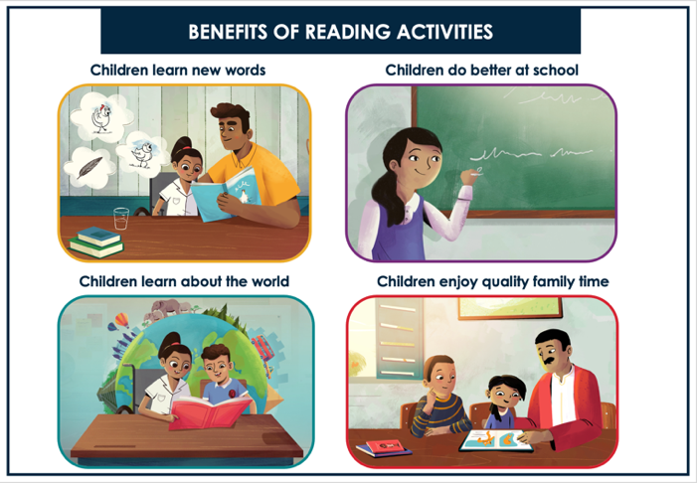 | INTRODUCE THE HANDOUT  There are many ways that reading activities can help your child. Whether looking at the pictures, talking about the story, or reading - books provide opportunities for children to learn many different things.  Each of these pictures show how reading activities can help your child become a more successful learner.
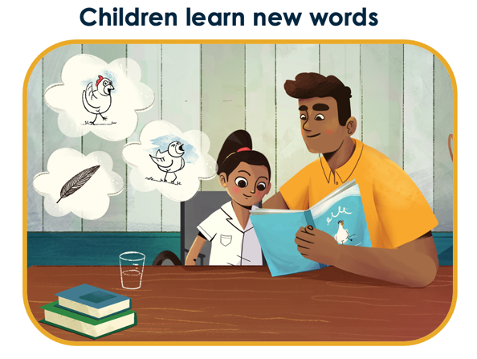 | Explain: Reading activities help children learn new sounds and words, and how to use them.  When you describe to your child what you see in the pictures and what is happening, you are building your child’s vocabulary and showing them how to use words in different ways.  For a very young child, you could point to a picture of a chicken and tell them: “That is a chicken”. If the child already knows the word “chicken”, you can say “Look, here is a chicken with white feathers. The chicken is walking on the grass, looking for something to eat”. In this way you are adding to what your child knows and understands.  For older children, you can ask questions about what they see in the picture and what is happening, or what they already know about something. This gives them the opportunity to practice using words and answering questions.
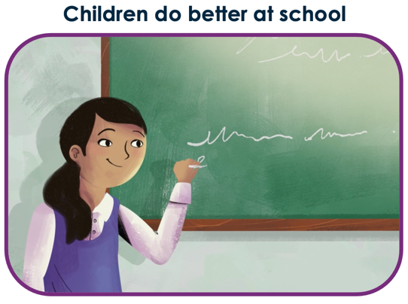 | Explain: When children spend time looking at pictures and have conversations about the story, they learn how to listen and concentrate, which helps them at school.
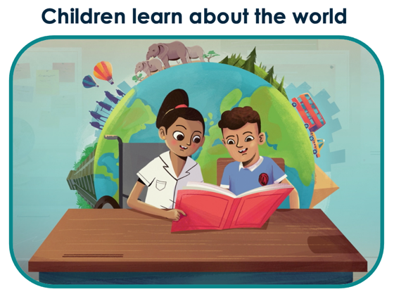 | Explain: When children have conversations about the story and characters, and what is happening and why, they learn more about other people and the world around them.  (provide examples from one of the books available to the caregiver, demonstrating how they could use what is in the book to help the child learn more about different things)
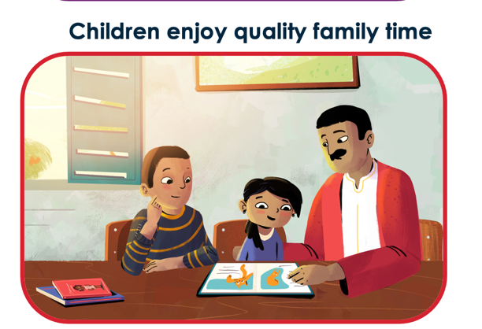 | Explain: Reading activities provide opportunities for you and your child to be close and have fun together, while you are learning at the same time.  Children learn best when they are relaxed and having fun, so make it a positive experience for you and your child. If your child is enjoying the activity, they are more likely to want to do it on a regular basis, which will make a big difference to their learning and development.  You can even involve other children or family members in your home to make it a fun family activity for everyone.

RELEVANT HANDOUT: R@H_V2_HANDOUTS 3_BEFORE, DURING, AFTER

- BEFORE THE STORY
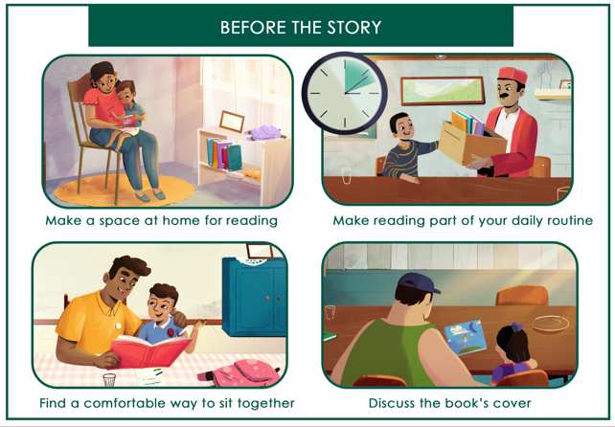 | INTRODUCE THE HANDOUT PAGE  This handout shows how you can set up and start your reading activity with your child – where to sit and how to sit, when to do the activity and how to introduce the book and story to your child.  I am going to talk about each of the pictures on the page and together we can discuss how you can make this work for you and your child.

Make a space at home for reading | Describe the picture/activity:  In the first picture, you can see a child and caregiver sitting together on a chair, looking at a book together.  Explain:  To encourage reading, make a space at home where you, your child and other family members can sit together for reading activities. You can use any seating area – it can be on the floor, at a table, bench, or couch – depending on where you have space. You can even set up a reading space outside.  Encourage practice:  Where at your home – inside or outside – do you think you could set up a space for reading activities? Would you use different places, or one specific place?
Make reading part of your daily routine  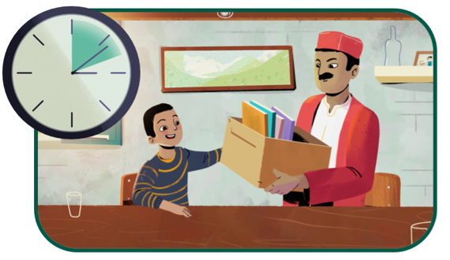 | Describe the picture/activity:  Here, you can see a clock/watch, and a caregiver walking over with books to his child.  Explain: You can make reading activities part of your daily routine. Even in a busy day, find some time to look at books or read together with your child. Even 10 minutes a day can make the world of difference.  Find a time that works best for your family. For example, you could make time towards the end of the day, when you want your child to come inside. Or you can try reading with your child before bed. This can help them to settle down after a busy day and fall asleep easier.  Encourage practice:  Where in your daily routine will you make time for reading activities? Will it work for you to do this daily? Why or why not? When could other family members or caregivers also participate in reading activities with your child?

Find a comfortable way to sit together  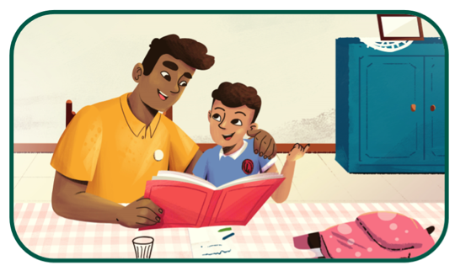 | Describe the picture/activity:  Here you can see the caregiver and child sitting close together at the table, looking at the book together.  Explain:  When you are ready to start your reading activity, find a comfortable way to sit with your child. You can sit with your child on your lap or you can sit side by side. You can sit on the floor, at a table, on a couch, or on the bed. There are many ways to sit, and you should do what is most comfortable for you and your child.  No matter how you decide to sit, it is important not to force your child to take part in the activity. If your child isn’t interested, your child won’t enjoy the activity and won’t learn from it. Rather try again another time.  Encourage practice:  How do you plan to sit with your child?
Discuss the book’s cover  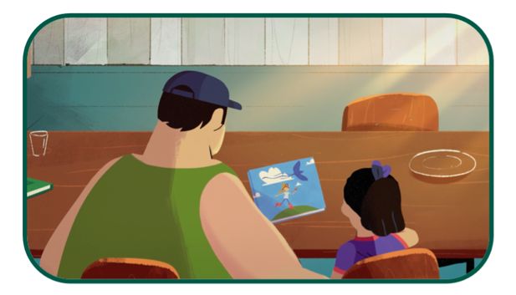 | Describe the picture/activity:  Here you can see the caregiver and child looking at the cover of the book.  Explain: Before opening the book, bring your child’s attention to the book’s cover. This helps children to focus on the book and helps them get ready for the activity.  Describe to your child what you see, or ask them to tell you what they see. Ask them what they think might happen in the story.  Encourage practice:  - Demonstrate to the caregiver how to discuss the book’s cover, using one of the books available to the caregiver.  - Then, invite the caregiver to try this out as well (providing encouragement and positive feedback)

- DURING THE STORY

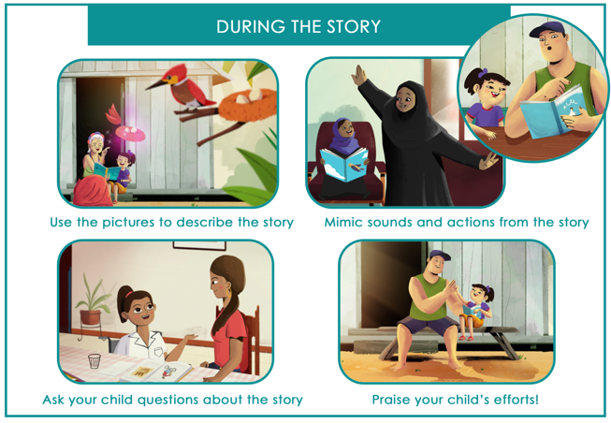 | INTRODUCE THE HANDOUT PAGE  Even if you can’t read yourself, you can help your child learn in many ways by going through a book together.  This handout shows different ways that you help your child learn – for example, by describing what you see in the pictures or asking questions about what is happening in the story.  Let’s go through these pictures together and discuss them.
Use the pictures to describe the story  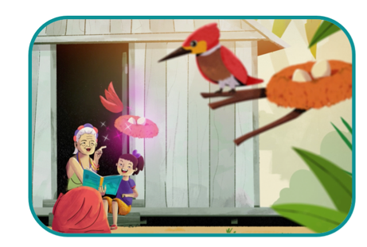 | Explain: As you go through the book, use the pictures to tell the story. Describe to your child what you see, and ask them to describe what they see.  For example, here you can see the caregiver is describing the bird that is in the book to her child. She can explain what the bird looks like, if your child points to a picture of a bird, you could add that the bird has red wings and a black beak, and is sitting on the tallest branch of the tree next to a nest. This helps the child to learn new words.  Encourage practice:  - Demonstrate to the caregiver how to describe the pictures in the story, using one of the books available to the caregiver.  - Then, invite the caregiver to try this out as well (providing encouragement and positive feedback)
Mimic sounds and actions from the story  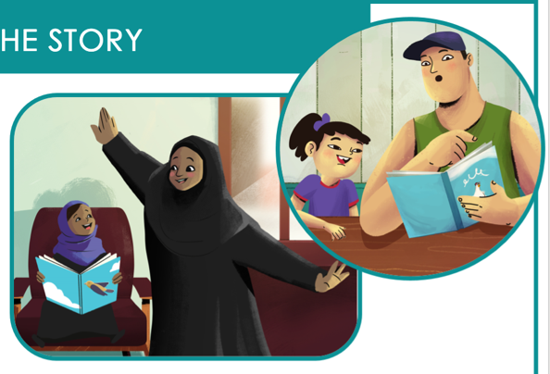 | Explain:  To bring the story to life, mimic different sounds and actions from the book with your child. Here [point to the female caregiver] you can see the caregiver is mimicking flying actions for her child. You can do the same with other sounds and actions based on what is happening in the story – for example, the sound of the wind, a truck, or a dog barking, or mimic a character jumping, clapping hands, hiding, or looking for something.  You can also use your face and voice to demonstrate different emotions from the story. Here [point to the male caregiver] you can see the caregiver is making a surprised sound and showing a surprised look on his face. You can do the same with other emotions, such as scared, angry, happy, confused or sad.  Encourage practice:  - Using one of the books available to the caregiver, demonstrate how to mimic sounds and actions and how to use your face and voice to demonstrate different emotions from the story.  - Then, invite the caregiver to try this out as well (providing encouragement and positive feedback)

Ask your child questions about the story  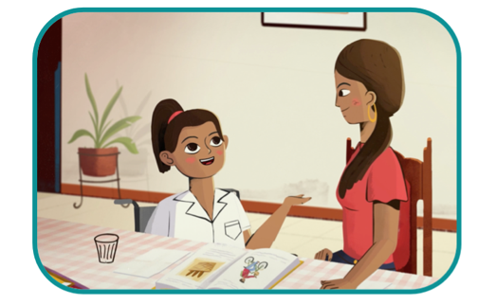 | Explain:  Ask your child as many questions as you can about the pictures and story. Use “Who, What, Where, Why and How” questions to encourage your child to answer using words other than “yes” and “no.  For example, questions about WHO is in the story, WHERE the story is taking place, WHAT is happening, and WHY or HOW this is happening.  Encourage practice:  - Using one of the books available to the caregiver, demonstrate how to use who, what, where, why, how questions.  - Then, invite the caregiver to try this out as well (providing encouragement and positive feedback)
Praise your child’s efforts  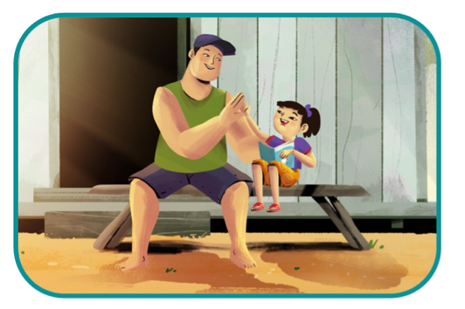 | Explain: No matter your child’s age, make sure you give them lots of praise! Kindness and praise helps children feel safe and confident, which helps them learn.  It might sound strange, but you don’t have to tell your child they are wrong or that they are making a mistake to help them learn. Rather, respond by offering them the correct word or answer:  So, if your child points to a tomato and calls it an apple, rather than saying “no, you are wrong, that’s a tomato”, you can respond by saying: “That is actually a tomato – it is red, like an apple, but it’s a tomato”  By correcting them in a positive way, you encourage them to keep talking and learning.  You are your child's first, and most important, teacher. The praise and support you give your child will help them enjoy reading and help them learn more from reading in future.  Encourage practice:  - Encourage the caregiver to focus on finding opportunities to praise their child during their next reading activity.  - Or: demonstrate to the caregiver different types of ways to show praise to their child  - Or: invite the caregiver to try it out (e.g., in a role play exercise)

- AFTER THE STORY
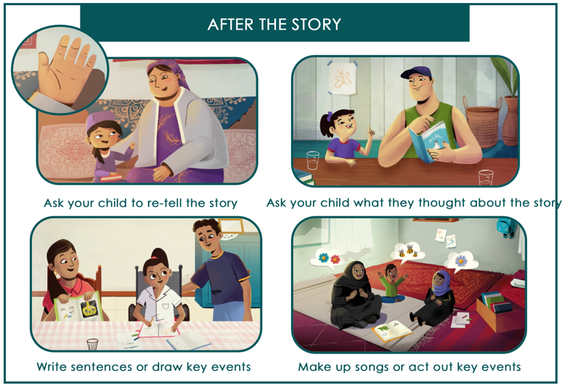 | INTRODUCE THE HANDOUT PAGE  This handout shows examples of easy activities you can do after the story that will help to strengthen your child’s learning.  Let’s go through these pictures together and discuss them.
Ask your child to re-tell the story  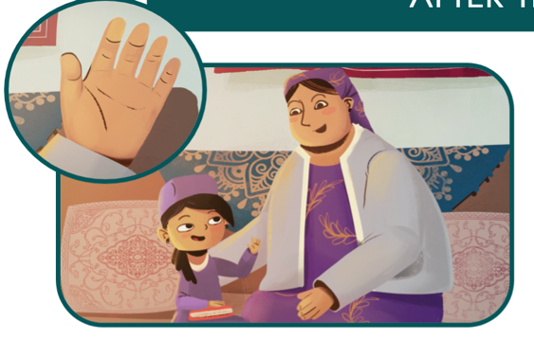 | Explain: Invite your child to re-tell the story using their own words.  [Hold up your hand and list the five questions below on your fingers, one by one]  You can help them retell the story by asking:  - Who is the story about?  - Where did the story take place?  - What happened in the beginning?  - What happened next?  - What happened in the end?  Encourage practice:  Encourage them to try it out with their child during their next reading activity.
Ask your child what they thought about the story  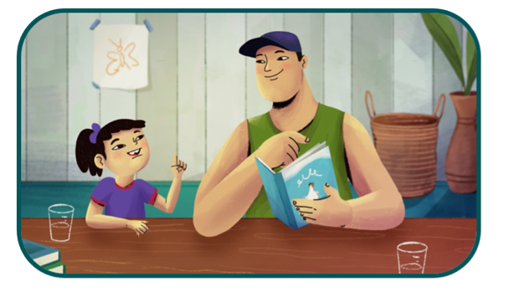 | Explain: Ask your child’s opinion of the story – what they liked or disliked and what they thought about different characters and events. You can ask questions like:  - “Who was your favorite character? Why?”  - “What was your favorite part of the story? Why?”  - “Did anything that happened surprise you?”  - “How would you feel if that happened to you?”  - “What would you have done differently?”  - “What would you have done if you were in their shoes?”  Encourage practice:  - Invite the caregiver to add more examples of things they could ask their child  - Encourage them to try it out with their child during their next reading activity.

Write sentences or draw key events  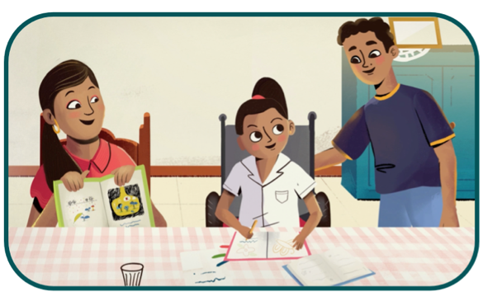 | Explain: Encourage your child to draw key events from the story, or for children who can already write, invite them to write sentences about the story. Younger children who are not writing yet can draw pictures about key events from the story. For older children who can write, let them practice writing words or sentences from the story, or let them write their own summary.  Encourage practice:  - Using one of the books available to the caregiver, provide some examples of pictures that the child could draw, or sentences that the child could write about the story.  - Invite the caregiver to make suggestions or give more examples.  - Encourage them to try it out with their child during their next reading activity.
Make up songs or act out key events  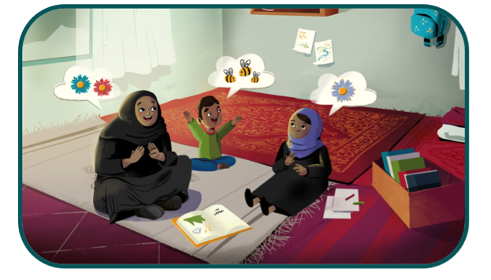 | Explain: Make up a song about the story or about new words from the book. This helps children to remember what they learned. For example, if the story is about a garden, you could make up a song about watering the plants, or about a bee that flies from flower to flower. Or you can choose a song you already know that is about the same topic as the story.  As a fun family activity, act out the story with your child, and invite other family members to play different characters.  Encourage practice:  - Using one of the books available to the caregiver, provide some examples of songs they could sing or how they could act out events from the story  - Invite the caregiver to make suggestions or give more examples.  - Encourage them to try it out with their child during their next reading activity.

RELEVANT HANDOUT: R@H_V2_HANDOUTS 1_DISABILITY

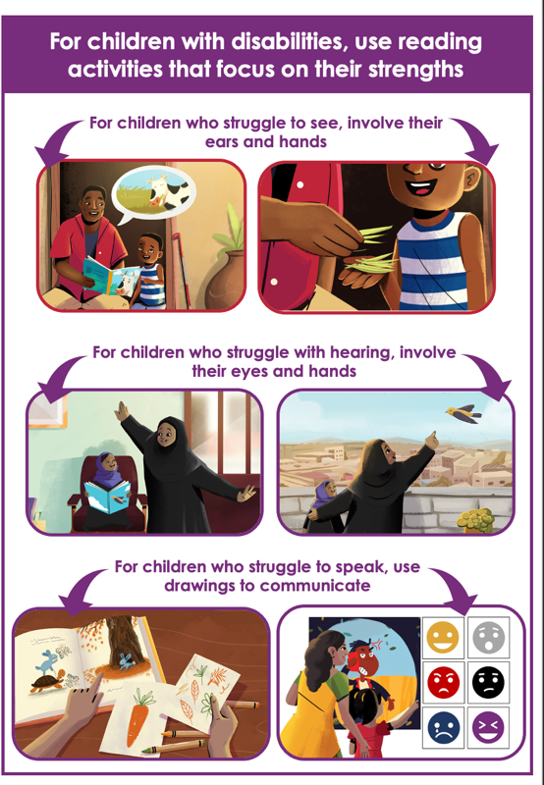 | INTRODUCE THE HANDOUT PAGE  All children, including children with disabilities can take part and benefit from reading activities.  Some disabilities may cause children to struggle or feel frustrated when it comes to handling books, listening, communicating, concentrating or reading.  This handout shows some examples of how you can make reading activities work for children with disabilities. These activities work for all children, not just those with disabilities.
For children who struggle to see, involve their ears and hands | Explain: Help children learn by involving different senses, such as touch and hearing.  For example, for children who can’t see, involve their other senses, such as hearing and touch. You can use your voice to tell the story, make sound effects and describe what is happening in the pictures. You can give your child objects to touch that relate to the story.  For example [point to the picture], if the story is about a cow eating grass, you can place some grass in your child’s hand, let them feel it and smell it.  Encourage practice:  - Using one of the books available to the caregiver, demonstrate how you can engage children’s ears and hands in the story (by making sounds, or finding objects for them to touch)  - Invite the caregiver to make suggestions or give more examples.  - Encourage them to try it out with their child during their next reading activity.
For children who struggle with hearing, involve their eyes and hands | Explain: For children who are deaf or struggle with hearing, involve their eyes and hands, and model actions or events from the story. You can show other visual examples of the same concept, or your child can draw a picture from the story or act out key events from the story.  All children benefit from having their hands, eyes, ears and voices working together to maximise learning.  Encourage practice:  - Using one of the books available to the caregiver, demonstrate how you can engage children’s eyes and hands in the story (by mimicking actions, and pointing out other things in their surroundings that link with the story)  - Invite the caregiver to make suggestions or give more examples.  - Encourage them to try it out with their child during their next reading activity.
For children who struggle to speak, use drawings to communicate | Explain: You can make drawings that match with the story, and children who struggle to speak can use the drawings to respond to questions.  In this example [point to the picture of the book on the left], you could draw pictures of different objects like a carrot (for the rabbit) and leaves (for the tree) and use them to ask your child questions:  “What do rabbits like to eat?”  “What covers the branches of the tree?” “What is falling on the ground?”  Or you can [point to the picture on the right] draw faces with different emotions on a page, and ask children to point to the emotion that corresponds with what the character is feeling.  Encourage practice:  - Using one of the books available to the caregiver, demonstrate how you can make drawings of different objects from the book and ask questions that allow the child to link the drawings to what happens in the story.  - Invite the caregiver to make suggestions or give more examples.  - Encourage them to try it out with their child during their next reading activity.

