Below are screenshots of the digital images (from the editable PowerPoint file), accompanied by a template script for a short audio recording that can be sent to caregivers as a voice note along with each image. Please note that these are template scripts, and teams can adapt the text as needed, depending on how these digital images will be used.
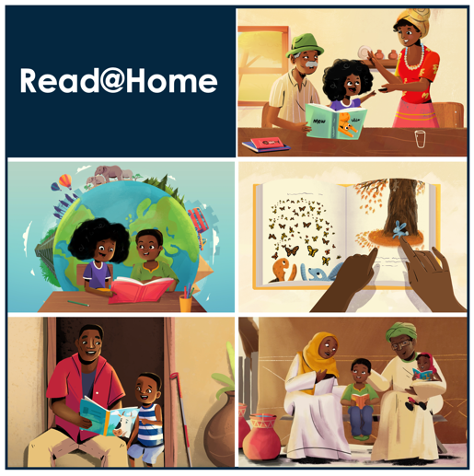 | Greetings! A warm welcome from the Read@Home team! Did you know that all children, no matter their age, benefit from reading activities at home? Just like teachers at school, parents and caregivers have an important role to play to help children learn to read and strengthen their reading skills. All caregivers can do this! Even if you can’t read yourself, you can help your child learn in many ways by going through a book together.
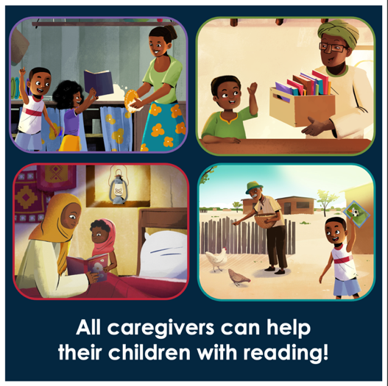 | All caregivers can help their children with reading! Even caregivers who cannot read themselves, who are busy or who don’t see children every day can help children with learning and reading in important ways. There are many reading activities that do not rely on the book’s written text, so you do not need to be able to read to use them. Over the next while, we will be sharing some of these activity ideas with you.
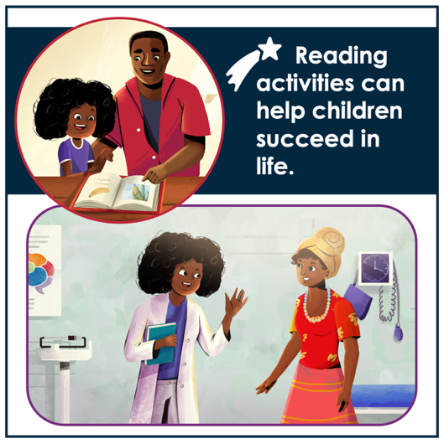 | Reading activities can help your child become a more successful learner. As caregivers, we want what’s best for our children. We want them to grow into successful, happy, healthy adults who contribute to society. Looking at books together and talking about them with your child is another great way to help build your child’s brain, develop their reading skills, and help them become successful learners.  So, find a few minutes a day, every day, to read with your child. It is one of the greatest gifts you can give them.
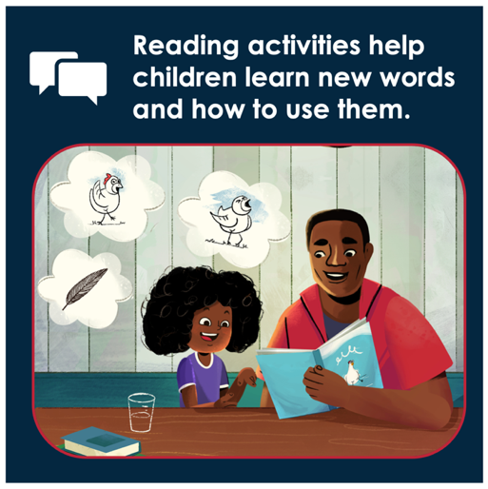 | How do children benefit from reading at home? Reading activities help children learn new sounds and words, and how to use them. When you describe to your child what you see in the pictures and what is happening, you are building your child’s vocabulary and showing them how to use words in different ways.
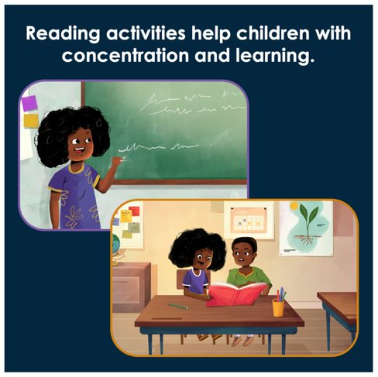 | How do children benefit from reading at home? Reading activities help children with concentration and learning! When children spend time looking at pictures and have conversations about the story, they learn how to listen and concentrate, which helps them at school.
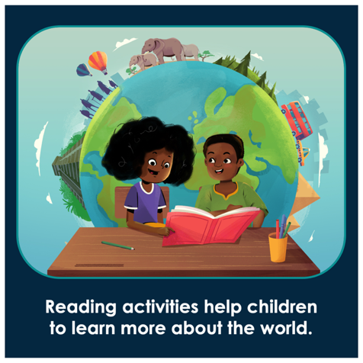 | How do children benefit from reading at home? Reading activities help children to learn more about the world! When children have conversations about the story and characters, and what is happening and why, they learn more about other people and the world around them.
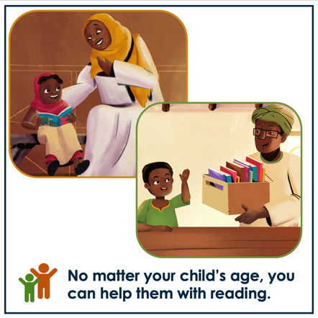  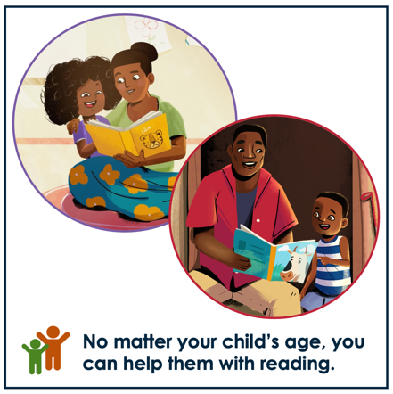 | As a caregiver, your involvement in reading activities is important at every age – whether your child is very young, or whether your child already knows how to read. By making some time each day to look at books together and talk about the pictures, you can be a good role model for using language and books. By spending this time together, you will also strengthen your relationship with your child. Your children will also learn to love books and stories. And when children read for fun, they do better at school.
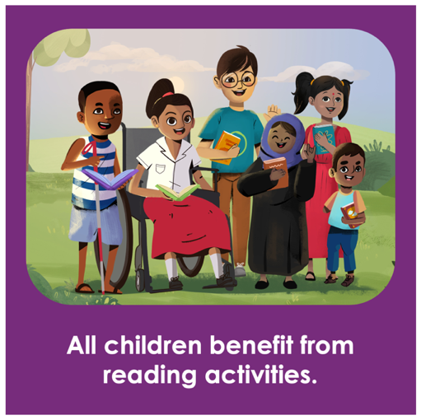 | All children, including children with disabilities can take part and benefit from reading activities. Some disabilities may cause children to struggle or feel frustrated when it comes to handling books, listening, communicating, concentrating or reading. If your child has a disability, focus on their strengths! For example, if a child struggles to see, involve their ears and hands. If a child struggles with hearing, involve their eyes and hands. If a child struggles to speak, help them use drawings and pictures to communicate.
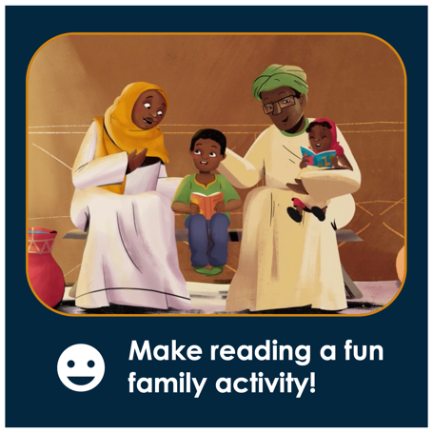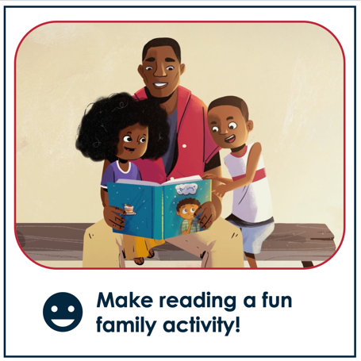 | Reading activities are important, but  they do not have to be serious!  This is an opportunity for you and your child to be close and have fun together, while you are learning at the same time.  Children learn best when they are relaxed and having fun, so make it a positive experience for you and your child. We hope you enjoy spending this time together!
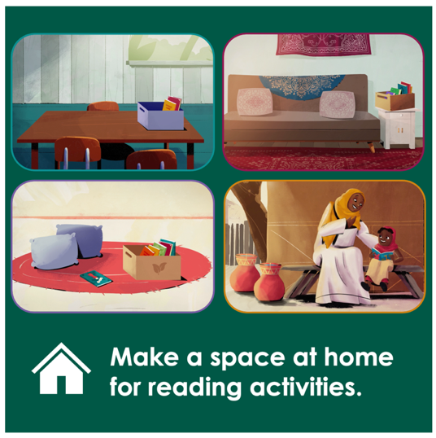 | Even before you open a book – there are many simple things you can do to encourage your child to enjoy books and reading activities. To encourage reading, make a space at home where you, your child and other family members can sit together for reading activities.
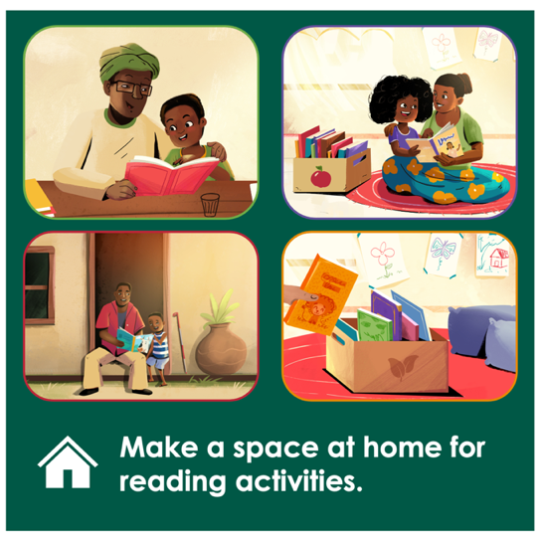 | You can use any seating area – it can be on the floor, at a table, bench, or couch – depending on where you have space. You can even set up a reading space outside. Where at your home – inside or outside – do you think you could set up a space for reading activities? Would you use different places, or one specific place?
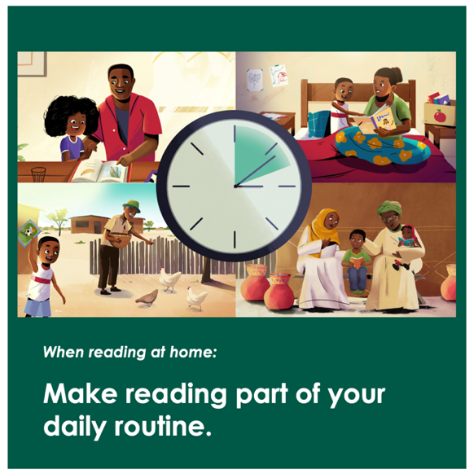 | The more time children spend looking at books, the more they learn. So, make reading part of your daily routine. Even in a busy day, find some time to look at books or read together with your child. Even 10 minutes a day can make the world of difference. Find a time that works best for your family. For example, you could make time towards the end of the day, when you want your child to come inside. Or you can try reading with your child before bed. This can help them to settle down after a busy day and fall asleep easier. Where in your daily routine will you make time for reading activities?
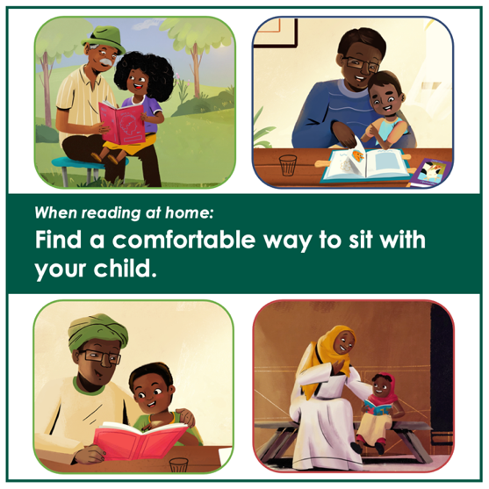 | When you are ready to start, choose a book for the activity, and find a comfortable way to sit together. You can sit with your child on your lap – this works well for younger children. You can sit next to your child on the floor, at a table, on a couch, or on the bed. There are many ways to sit, and you should do what is most comfortable for you and your child.
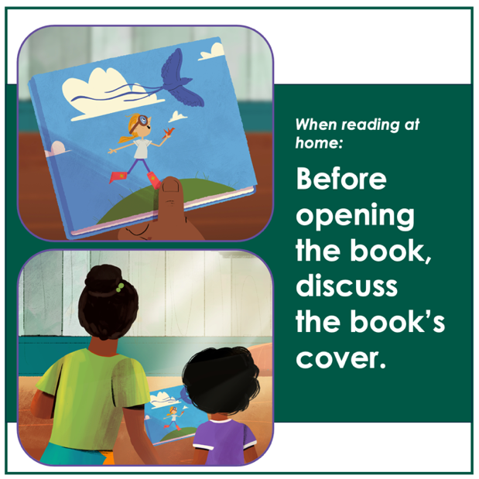 | Before opening the book, bring your child’s attention to the book’s cover.  This helps children to focus on the book and helps them get ready for the activity.  You can describe to your child what you see, or you can ask your child to tell you what they see, and ask them questions about it. For example, you could say:  “Look, this child is running outside – what does she have in her hand? What do you think it is made of?”  “The child is looking up at the sky - what can we see flying above her? What else can you see in the sky?”
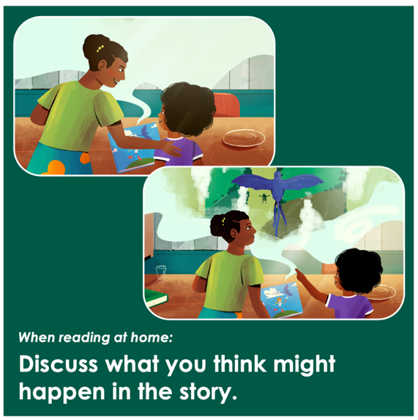 | You can use the book’s cover to discuss what you think might happen in the story. Asking children what they think will be happening helps them to be more focused and encourages them to be curious about the story.
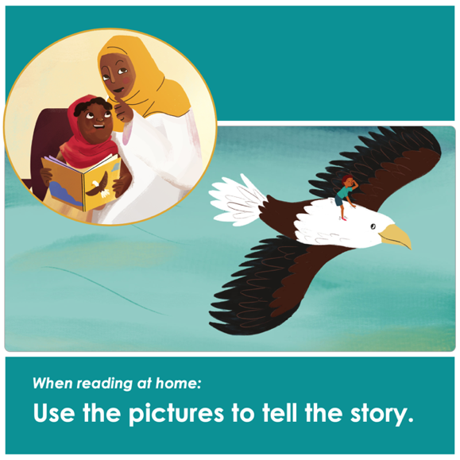 | As you go through the book, use the pictures to tell the story. This works especially well for younger children or children who can’t read yet. Make it fun by using a lively voice to tell the story, with different voices for different characters. If you have a book at home, take a look at the pictures in the book. What could you tell your child about the pictures in the book? Why don’t you try some time this week to talk about the book’s pictures with your child?
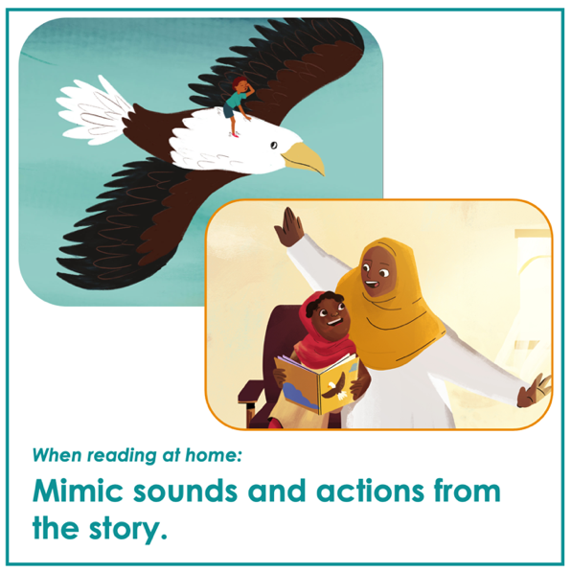 | To bring the story to life, mimic different sounds and actions from the book with your child. For example, you can make flying sounds and mimic flying actions for your child. You can do the same with other sounds and actions based on what is happening in the story – for example, the sound of the wind, a truck, or a dog barking, or mimic a character jumping, clapping hands, hiding, or looking for something.
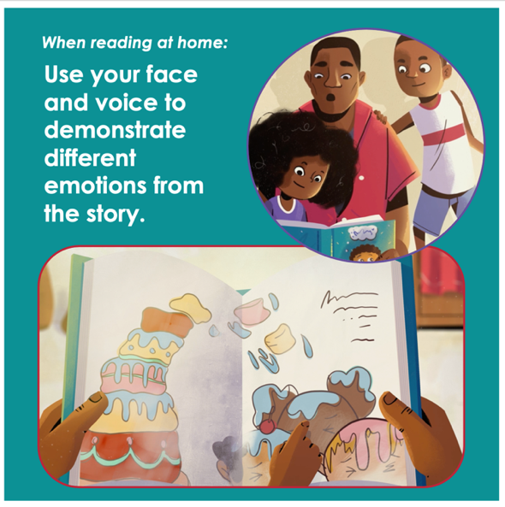 | Use your face and voice to demonstrate different emotions from the story.  For example, if something in the book happens that takes the character by surprise, you could make a surprised sound and show a surprised look on your face. You can do the same with other emotions, such as scared, angry, happy, confused or sad.
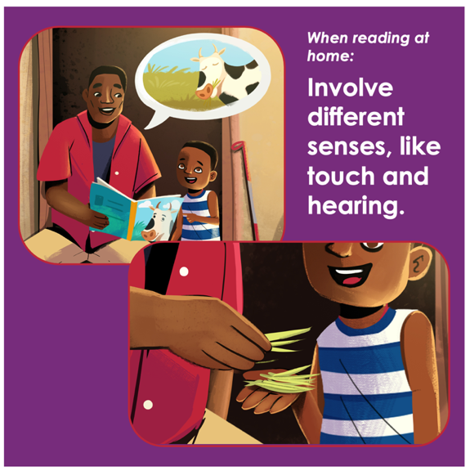 | All children benefit from having their hands, eyes, ears and voices working together to maximise learning. For children with disabilities, you can work with their sensory strengths. For children who can’t see, involve their other senses, such as hearing and touch. You can use your voice to tell the story, make sound effects and describe what is happening in the pictures. You can give your child objects to touch that relate to the story. For example, if the story is about a cow eating grass, you can place some grass in your child’s hand, let them feel it and smell it.
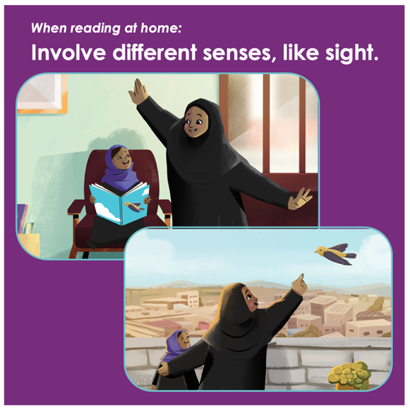 | For children who are deaf or hard of hearing, involve their eyes and hands, and model actions or events from the story. You can show other visual examples of the same concept, or your child can draw a picture from the story or act out key events from the story. These activities can be helpful and fun for all children. Do you think your child will enjoy it?
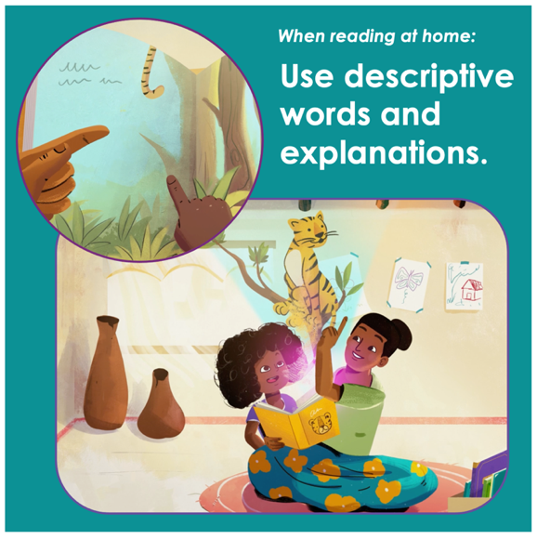 | When reading at home, use descriptive words and explanations to increase your child’s knowledge and vocabulary. For example, if your child points to a picture of a tiger, you could add that the tiger is yellow with black stripes, that the tiger has a long tail and that the tiger is sitting on the tallest branch of the tree.
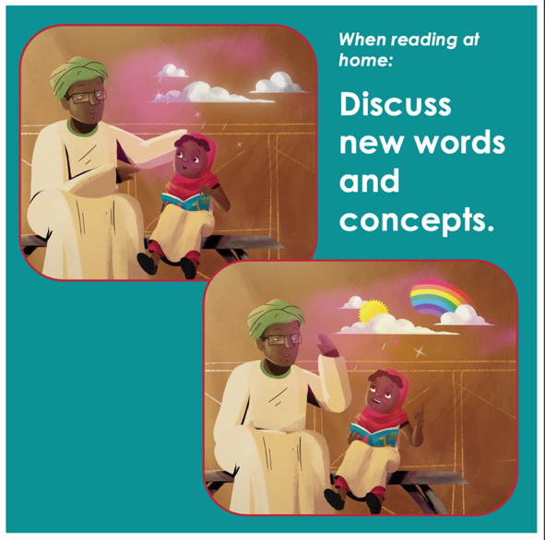 | During the story, stop to talk about words or concepts that your child might not yet know or understand. For example, if there is a picture of clouds, you could explain to your child that clouds sometimes appear in the sky, and that clouds make rain. Or you can add that sometimes after it rains, a rainbow can appear in the sky. These explanations help to increase your child’s understanding and knowledge of different things.
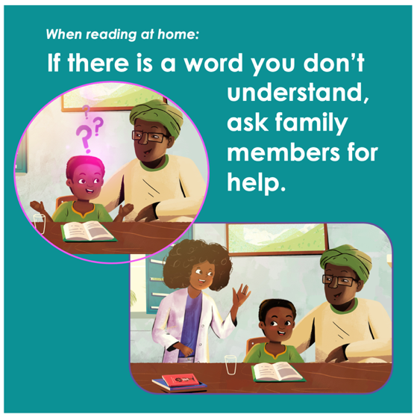 | If there is a word or concept that is unfamiliar to you and your child, ask older siblings, family or friends to help.  Not knowing or understanding something is nothing to be ashamed of. Be honest with your child if you don’t know something, and together you can ask someone to help explain things to you and your child. This shows your child that learning is a life-long process, and that you can discover new things together. If you needed help explaining something to your child, who in your household could you ask? Who outside your household could you ask?
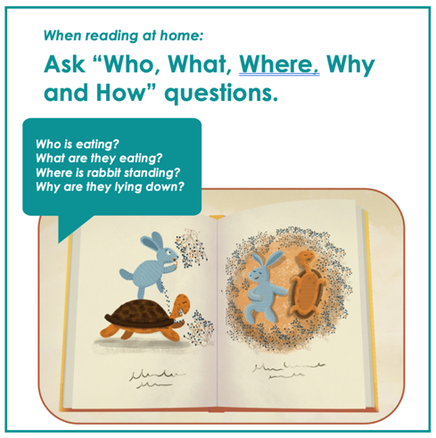 | Ask your child as many questions as you can about the pictures and story. “Who, What, Where, Why and How” questions encourage your child to answer using words other than “yes” and “no. Questions like:  Who is eating?  What are they eating?  Where is rabbit standing?  Why are they lying down?  How are they feeling?  Your questions will help them talk about what they see in the pictures and think about what is happening.
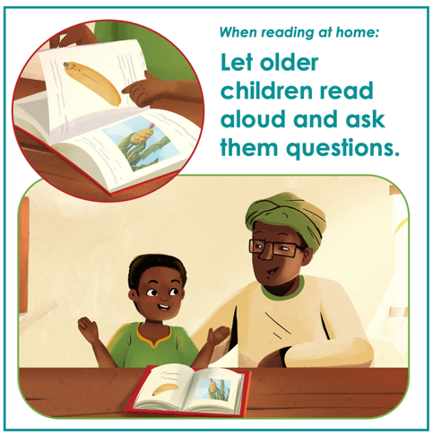 | Let older children read aloud and ask them questions about what they are reading. Use the pictures and what your child is reading to ask questions about WHO is in the story, WHERE the story is taking place, WHAT is happening, and WHY or HOW this is happening.
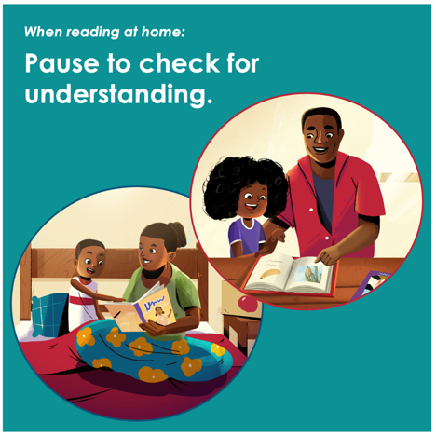 | As you go through the book, stop at different places to let your child think about what has happened so far.  You can ask:  Who have you met in the story? What have they been doing? What has happened? Why did this happen?
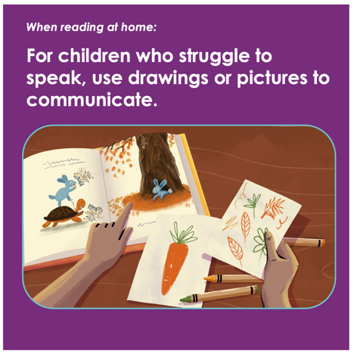 | You can make drawings that match with the story, and children who struggle to speak can use the drawings to respond to questions. You could draw pictures of different objects like a carrot (for the rabbit) and leaves (for the tree) and use them to ask your child questions:  “What do rabbits like to eat?”  “What covers the branches of the tree?”  “What is falling on the ground?”
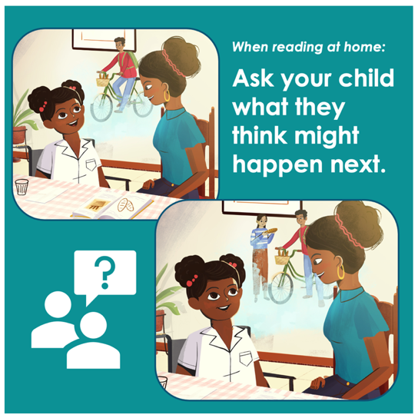 | Before moving on to the next page, ask your child what they think will happen next. For example, if someone in the story went to go buy some bread, you could ask your child “What do you think will happen next?” This helps your child to think about where they might be going, what they might be doing when they get there, or what might happen later in the story. Even if your child guesses wrong, they are still practicing their thinking skills!
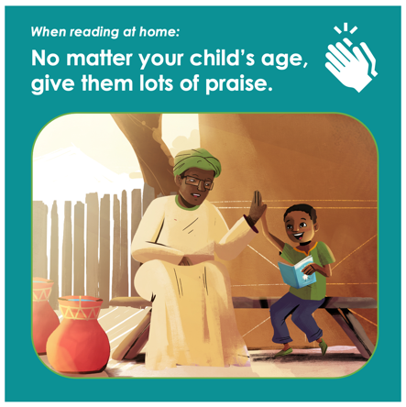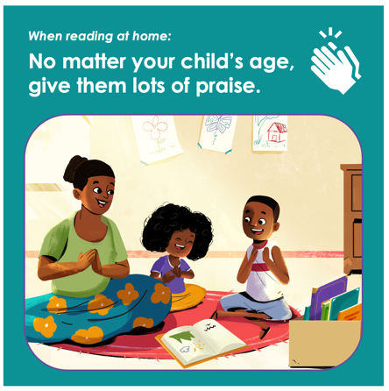 | No matter your child’s age, make sure you give them lots of praise! It might sound strange, but you don’t have to tell your child they are wrong or that they are making a mistake to help them learn. Rather, respond by offering them the correct word or answer. By correcting them in a positive way, you encourage them to keep talking and learning. We hope you find moments to praise your child during your next reading activity!
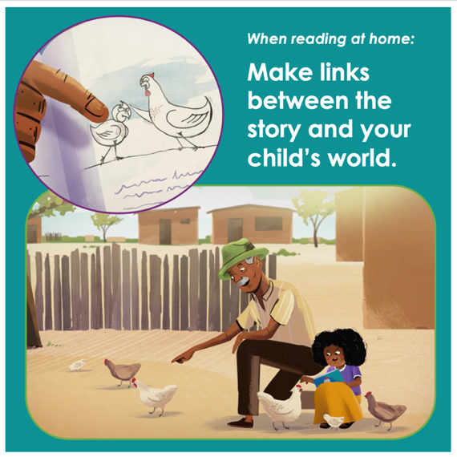 | Stories are a great way to help your child learn about what happens around them. You can connect what you are seeing or reading to things in your child’s world.  For example, if there are chickens in the story, you could point out to your child that you also have chickens outside your house that you feed every morning. You can do this with many things – your child’s surroundings, animals, household objects, clothing, or activities – there will be many opportunities to make links between the pictures in the book and your child’s world. This is a great way to help children remember new words, and improve their understanding of different things.
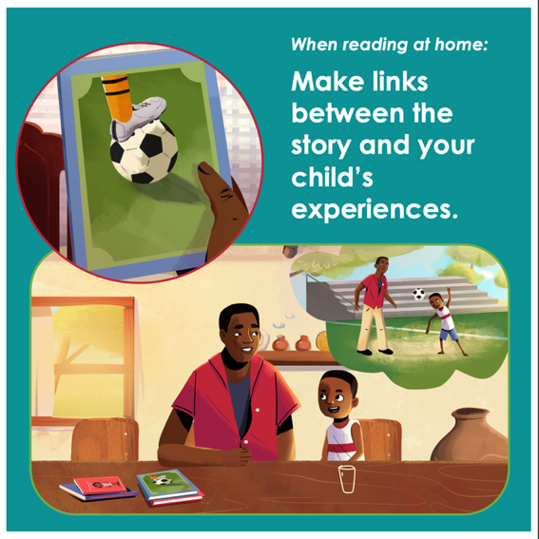 | Connect what you are seeing or reading to your child’s personal experiences, other stories or world events.  Ask them what the story reminds them of, or how an event is the same or different from their own experiences. You can ask questions like: “What does this remind you of? How is what happens here the same? How is it different? Does this remind you of someone or something you know?”
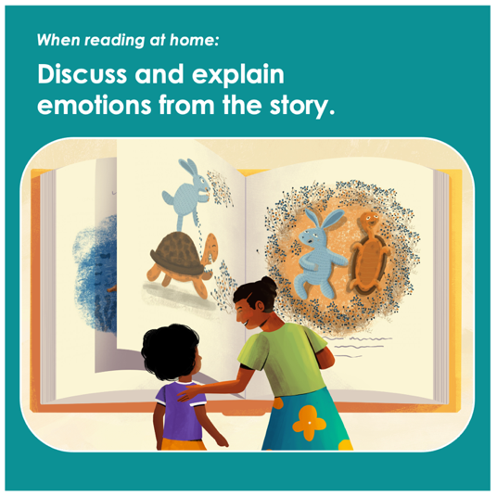 | Talk about the emotions of the characters and explain them to your child. As you look at the pictures together, point to the faces in the picture and say:  “He looks happy. She looks excited. He looks surprised.” Or you can ask your child: “Who is sad on this page? Who is happy on this page?” Explain to your child why characters feel certain emotions. You can do this by asking “Why do you think they look happy?” and wait for your child’s answer. If your child does not reply, then you can suggest the reason
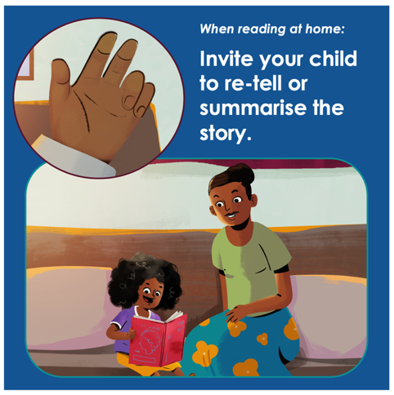 | After you have gone through the book with your child, invite them to re-tell the story using their own words.  You can help them retell the story by asking:  - Who is the story about?  - Where did the story take place?  - What happened in the beginning?  - What happened next?  - What happened in the end?
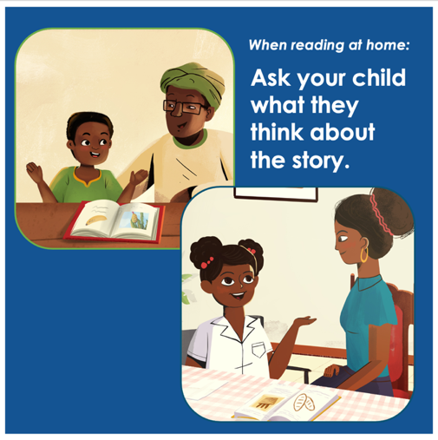 | Ask your child’s opinion of the story – what they liked or disliked and what they thought about different characters and events. You can ask questions like:  - “Who was your favorite character? Why?”  - “What was your favorite part of the story? Why?”  - “Did anything that happened surprise you?”  - “How would you feel if that happened to you?”  - “What would you have done differently?”
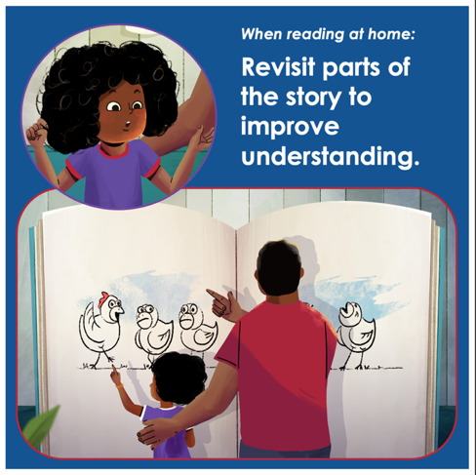 | After you have gone through the book, you can re-read or revisit parts of the story to improve your child’s understanding of events, new concepts or words. Children love reading the same book over and over, and this repetition will strengthen their learning.
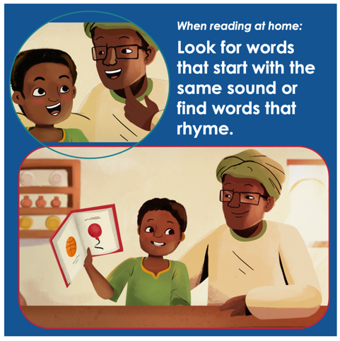 | Help your child think about the letter or sound that a word starts with, and encourage your child to find other words that start with the same sound. You can also choose a word from the story, and think about words that rhyme.
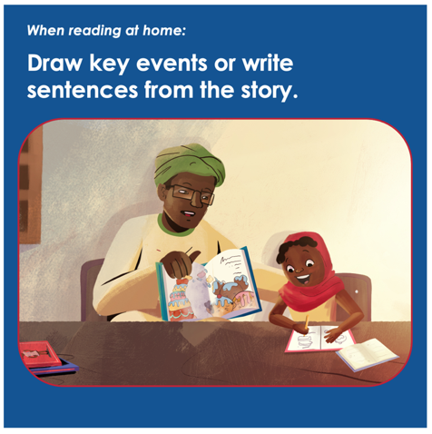 | Younger children who are not writing yet can draw pictures about key events from the story. For older children who can write, let them practice writing words or sentences from the story, or let them write their own summary.
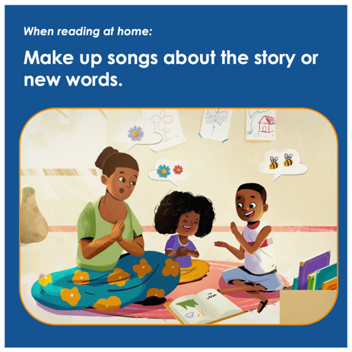 | Make up a song about the story or about new words from the book. This helps children to remember what they learned. For example, if the story is about a garden, you could make up a song about watering the plants, or about a bee that flies from flower to flower. Or you can choose a song you already know that is about the same topic as the story.
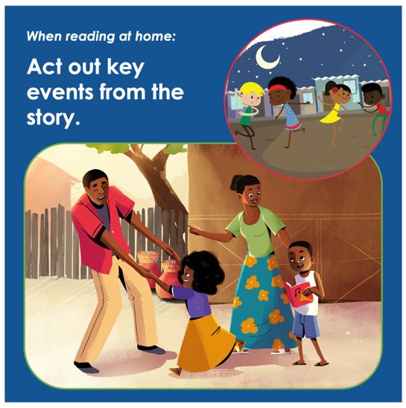 | As a fun family activity, act out the story with your child, and invite other family members to play different characters.  We hope you find a special time and place to do reading activities with your child. This is an opportunity for you and your child to be close and have fun together, while you are learning at the same time.

